 |  | TERMO DE ACEITE TÉCNICO
Solicitante: VIVO- Projeto Escolas Rurais
NOC/Operador: Rogerio Momi Frias |  |  | Cliente: VIVO
Empresa  EMC Brasil | VSAT-ID  VIVO-PER- |  | Link kbps  256/128 | Plataforma  VSAT
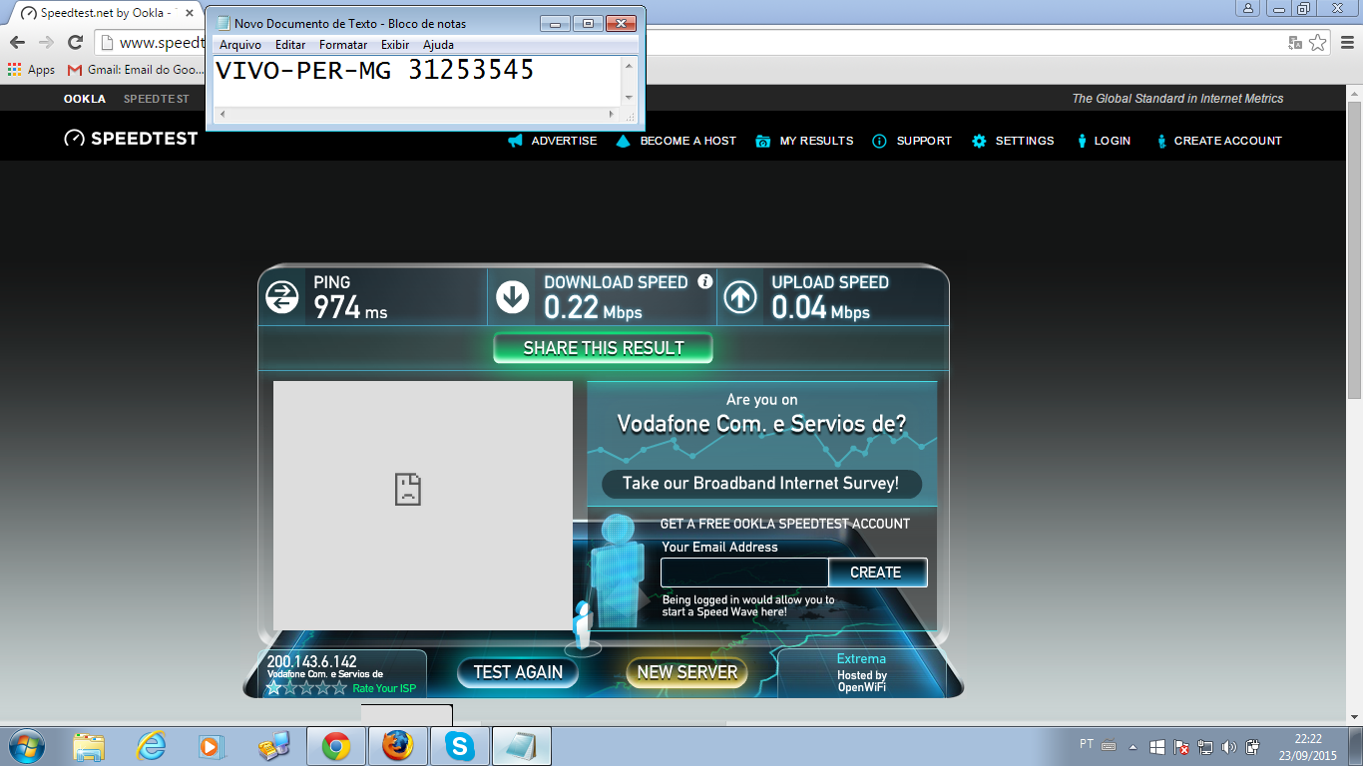

Satellite (DVB) RX Configuration
--------------------------------
Auto start : Enabled
Max MODCOD : 23 16APSK-9/10 (SNR threshold: 23.5 dB)
RX watchdog : 15 minute

Idx Pri SymbRate[Msps] Freq[GHz] Mode PopId Enable
* 0 0 9.320000 12.055825 DVB-S2 4 Yes
1 1 0.000000 0.000000 DVB-S2 2 No

Satellite (DVB) Receiver Status
--------------------------------
Rx State : On
DVB State : Forward link up
Network : 1326, GlobalIP@Telstar-14R
Frequency : 12.055737 GHz
Symbol Rate : 9.319984 Msps
S2 ModCod
- receiving : 1 QPSK-1/4
- current max : 23 16APSK-9/10
Pilot : On
Frame length : Short
DVB S2 Mode : ACM
Roll off : 0.25
SNR : 15.4 dB
Input Power : -18 dBm

Satellite (DVB) TX Configuration
--------------------------------
Auto start : Enabled
IDU Output Power : -30 dBm
IDU Max Output Power: 0.0 dBm
ODU Output Power : 34.7 dBm
EIRP : 48.0 dBW
Default CW Frequency: 0.000000 GHz
ATM mode : VC-Mux
Header Compression : None

Satellite (DVB) Transmitter Status
--------------------------------
State : On (TDMA)
IDU Output Power : -15.5 dBm
ODU Output Power : 35.2 dBm
EIRP : 48.5 dBW
Eb/No : 14.5 dB
Header Compression : Disabled
Timing correction : 139 us (260602 us)
Frequency correction: -470 Hz

Pinging 10.53.0.198 with 32 bytes of data:

Reply from 10.53.0.198: bytes=32 time=1871ms TTL=61
Reply from 10.53.0.198: bytes=32 time=1478ms TTL=61
Reply from 10.53.0.198: bytes=32 time=921ms TTL=61
Reply from 10.53.0.198: bytes=32 time=659ms TTL=61

Ping statistics for 10.53.0.198:
Packets: Sent = 4, Received = 4, Lost = 0 (0% loss),
Approximate round trip times in milli-seconds:
Minimum = 659ms, Maximum = 1871ms, Average = 1232ms

C:\Documents and Settings\Administrator.DVB-RCS>ping 10.29.3.209

Pinging 10.29.3.209 with 32 bytes of data:

Reply from 10.29.3.209: bytes=32 time=636ms TTL=61
Reply from 10.29.3.209: bytes=32 time=1284ms TTL=61
Reply from 10.29.3.209: bytes=32 time=1108ms TTL=61
Reply from 10.29.3.209: bytes=32 time=1657ms TTL=61

Ping statistics for 10.29.3.209:
Packets: Sent = 4, Received = 4, Lost = 0 (0% loss),
Approximate round trip times in milli-seconds:
Minimum = 636ms, Maximum = 1657ms, Average = 1171ms

ping 8.8.8.8
64 bytes from 8.8.8.8: time=820 ms
64 bytes from 8.8.8.8: time=870 ms
64 bytes from 8.8.8.8: time=1510 ms
64 bytes from 8.8.8.8: time=560 ms
64 bytes from 8.8.8.8: time=550 ms

--- 8.8.8.8 ping statistics ---
5 packets transmitted, 5 received, 0.00 percent packet loss
rtt min/avg/max = 550/860/1510 ms

